**The Sarah Street Scramble is in the books, and it was a big hit**

**56 golfers were there…on time for an 8 AM tee off (A Serbian Miracle no doubt)**

**Congratulations to our winning team, Larry, Samantha and Milana Milosh…and whoever else they played with whose shots they probably didn’t need to take.**

**Second place went to Adam Somma’s team, who came in from Chicagoland, to claim 2nd place. He treated 3 customers to golf (hey, great idea!!!). Thanks Adam.**

**Serb Club President Zack Krieger played in a group of young guns, and although didn’t take home the trophy, was close at 19 strokes behind.**

**It wasn’t the same without the Bill Krieger, Eli Shorak, Mike Tassari and Dane Topich Foursome.**

**Rumor has it they have been working out with LeVeon Bell while all of their contracts get re-negotiated. Maybe they will be there next year.**

**Skill prize winners were Samantha Milosh, Scott Somma and John Sargeant Sr.**

**A skill prize should have gone to Gary Gojsovich for double hitting a chip shot, now that is skill**

**The net proceeds of our event was $6,901.**

**Thanks to all of our players, sponsors, donors and workers, especially Rande and Georgia Somma who came through with a surprise special donation.**

**Rob Winovich, Mark Winowich and the ASC Foundation Board**

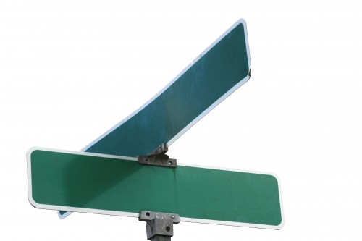 **Hvala to our Sponsors**

**Sarah St**

**Scramble**

**The Mario**



**The Margaritaville**



**The Cupka**



**The Nadine**



**The Stone’s Bar**



**Sarah St**

**Scramble**

Special Thanks to Ironwood Golf, Gojsovich Catering, Guy Defebo and ASC for all game day efforts.